Homework 2:
Creating & manipulating dataframes
due September 21, 2026 (before 10:20)
This assignment involves (a) recapping the things shown during the lecture by going through my example R script, and then applying all these things on your own by (b) numerically and visually inspecting variables in an existing dataframe, (c) creating new dataframes, and (d) reshaping dataframes from wide to long formats. The existing dataframe used in this assignment is the same one as last week (with the parenting data.

PART A: Recap materials from lecture
Before you start with parts B to D, I highly recommend going through my example R script that shows again the things we covered in the lecture. This R script is called something likle ExampleScript_Week02.R and can be found on Brightspace under Week 2. For this part, you do not have to hand in anything.

PART B: Describing variables (numerically and visually)
You will be repeatedly asked throughout your research career (and this course) to numerically and visually inspect variables in existing dataframes. There are numerous descriptive statistics and graphical representations that can be used to inspect variables. Most of the time, there are R functions that will automatically calculate statistics and graphs for you, but it is also important to be able to manually calculate various statistics and create specific types of graphs. So, in this part of the assignment you are asked to initially load (or import) the dataframe, and to calculate some basic statistics both automatically and manually for one variable in the dataframe.

- Provide the R code that loads the parenting dataframe. You can either load the csv file that you created in last week's homework. Or, if you prefer, you can import the SPSS .sav file again (which you can find on Brightspace under Week 1 -> Homework 1). If you import the SPSS file, then be sure to include the library() command to load the foreign package.

getwd()
setwd("/Users/heyanyan/Desktop/2025_Master/2026-2027/2026_FA_B1/26F_R/Week 1")
df <- read.csv("parenting.csv")
df

- Compute and report the mean, median, minimum and maximum values, range, and the interquartile range (command IQR()) of variable socioeconomic status (SES). Please include both the R code as well as the number that you compute.

mean(df$SES) #41.03136
median(df$SES) #45
min(df$SES) #0
max(df$SES) #81
range(df$SES) #0 81
IQR(df$SES) #46

- Provide the R code that "manually" calculates both the descriptive and the inferential variance of SES and also the descriptive and inferential standard deviation of SES. Also report the actual variance and SD values that you computed this way.

# descriptive variance
var_des <- sum((df$SES - M)^2) / N
var_des #646.6607

# inferential variance
var_inf <- sum((df$SES - M)^2) / (N -1)
var_inf #648.418

# descriptive standard deviation
SD_des <- sqrt(var_des)
SD_des #25.42953

# inferential standard deviation
SD_inf <- sqrt(var_inf)
SD_inf #25.46405

- Use the var() and sd() commands to "automatically" calculate the inferential variance of SES and report these numbers. Do you get the same numbers as the ones you computed above under point 3.? Which are the same, which differ? Why?

> var(df$SES)
[1] 648.418 => 648.418
> sd(df$SES)
- 25.46405 => 25.46405
The same

PART C: Creating a “wide” dataframe
There are some instances in which you will need (or want) to create a new dataframe. This part of the assignment asks you to create a dataframe with categorical and continuous variables, and to visualize these newly created variables.

- Provide the R code that creates a dataframe in "wide" format, which consists of at least 10 rows of data (it can include more) and six columns (variables). The first column should be a unique identifier indicating the participant code (so each row has a different value). The second column should be a categorical demographic variable with two factor levels (e.g., gender). The 3rd column should be a continuous demographic variable (e.g., age or SES or IQ or how tall a person is, etc). Columns 4-6 should be continuous variables that represent one construct assessed three times (i.e., a repeated measure).

matrix <- matrix(data = NA, nrow = 10, ncol = 6)
matrix
df_wide <- as.data.frame(matrix)
df_wide
names(df_wide) <- c("pp_code", "gender", "age", "FAT_1", "FAT_2", "FAT_3")
df_wide$pp_code <- c('1','2','3','4','5','6','7','8','9','10')
df_wide$gender <- c('f','f','m','m','f','m','m','f','f','m')
df_wide$age <- c(20,30,25,20,24,32,35,21,22,27)
df_wide$FAT_1 <- c(6,7,7,6,8,5,8,9,5,10)
df_wide$FAT_2 <- c(8,8,6,6,9,8,9,10,10,10)
df_wide$FAT_3 <- c(9,9,8,8,9,10,7,8,9,8)
df_wide

> df_wide
pp_code gender age FAT_1 FAT_2 FAT_3
1 1 f 20 6 8 9
2 2 f 30 7 8 9
3 3 m 25 7 6 8
4 4 m 20 6 6 8
5 5 f 24 8 9 9
6 6 m 32 5 8 10
7 7 m 35 8 9 7
8 8 f 21 9 10 8
9 9 f 22 5 10 9
10 10 m 27 10 10 8

- What does the distribution of the continuous demographic variable look like? Provide a density plot of the continuous demographic variable. For this and all the following figures, please try to use APA style numbering/title/notes (if you are unsure how to do this, here are two things where you can look this up:
- the word document "APA_sample-figures.docx" I uploaded to Brightspace --> Course syllabus, cheat sheets, and other stuff
- https://apastyle.apa.org/style-grammar-guidelines/tables-figures/figures)
To do these APA things (namely adding a Figure number, a figure title, and the figure notes) I would recommend to add these in word; adding these things directly in R can be quite a pain! Since you have to be able to create these APA things at the very latest for the take-home exams (and for your thesis and publications etc), it's good to already start practicing this early on. Some other things how to make sure the figure is pretty (such as that the fonts are large enough, to have nice axis labels, etc -- all things you do in R!), we'll learn in week 3.

Figure 1
The densityplot distribution of age
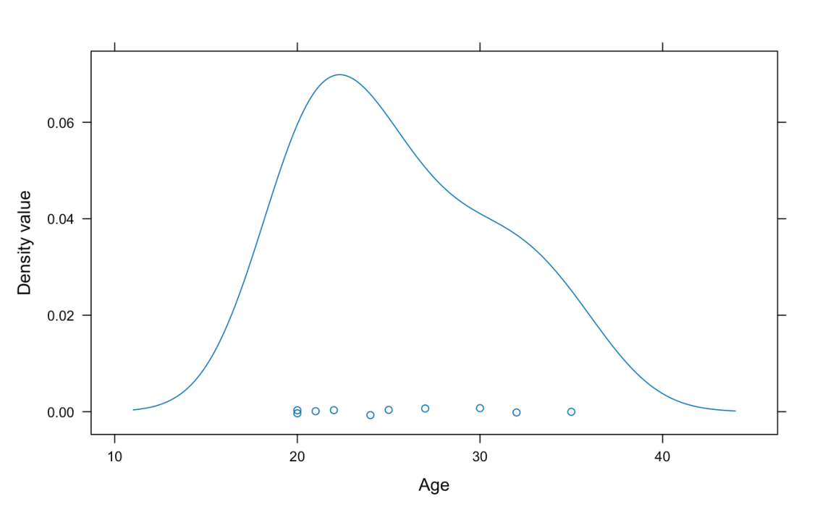
Note. This is the continuous age variable densityplot.

- What do the distributions of the repeated measures variable look like? Provide boxplots of the three continuous (repeated) measures (as mentioned before, please use APA-style for this and all following figures).
Figure 2
The boxplot distribution of FAT trial 1
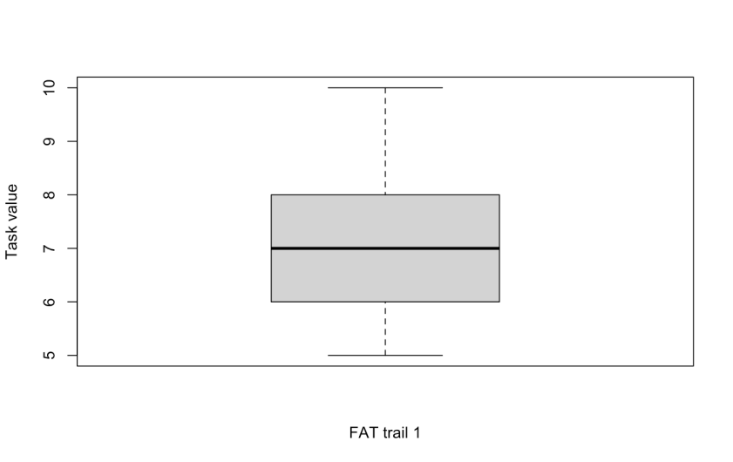
Note. This is the repeated measure FAT trial 1 boxplot.

Figure 3
The boxplot distribution of FAT trial 2
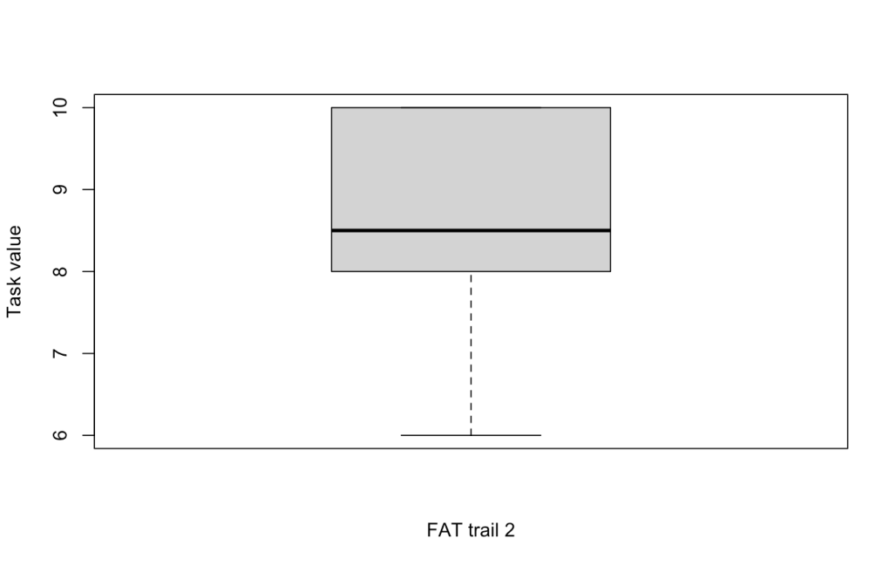
Note. This is the repeated measure FAT trial 2 boxplot.

Figure 4
The boxplot distribution of FAT trial 2
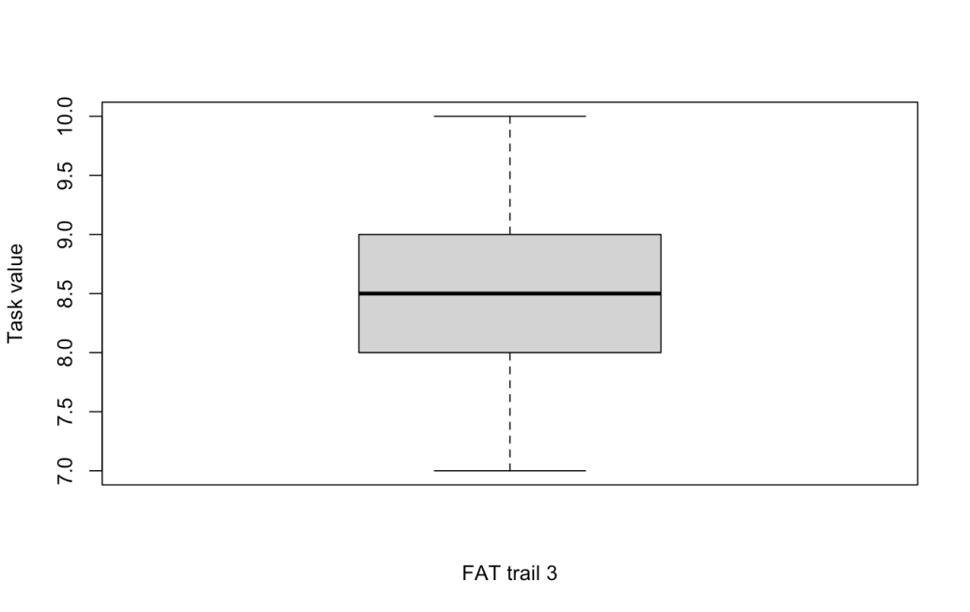
Note. This is the repeated measure FAT trial 3 boxplot.

PART D: Reshaping dataframes
There are instances in which you will also need (or want) to reshape a dataframe from either wide to long format or vice versa (long to wide). For instance, in order to graphically display repeated measures data using ggplot2 (the R package we will use to create various “presentation-quality” graphs), the data should be in a long format, so any data in a wide format needs to first by converted. So, this part of the assignment asks you to reshape the newly created dataframe in wide format to a long format, and to visualize the continuous repeated measure.
- Provide the R code that reshapes the dataframe created in Part C to a long format using the melt() and reshape() commands.

df_wide
install.packages("reshape")
library(reshape)
df_long_1 <- melt(df_wide,id.vars = c("pp_code","gender","age"), measured.vars = c("FAT_1", "FAT_2", "FAT_3"))
df_long_1

df_long_2 <- reshape(df_wide, idvar = c("pp_code","gender","age"), varying = c("FAT_1", "FAT_2", "FAT_3"),timevar = "trail1or2or3", v.names = "rating", direction = "long")
df_long_2

> df_long_1
pp_code gender age variable value
1 1 f 20 FAT_1 6
2 2 f 30 FAT_1 7
3 3 m 25 FAT_1 7
4 4 m 20 FAT_1 6
5 5 f 24 FAT_1 8
6 6 m 32 FAT_1 5
7 7 m 35 FAT_1 8
8 8 f 21 FAT_1 9
9 9 f 22 FAT_1 5
10 10 m 27 FAT_1 10
11 1 f 20 FAT_2 8
12 2 f 30 FAT_2 8
13 3 m 25 FAT_2 6
14 4 m 20 FAT_2 6
15 5 f 24 FAT_2 9
16 6 m 32 FAT_2 8
17 7 m 35 FAT_2 9
18 8 f 21 FAT_2 10
19 9 f 22 FAT_2 10
20 10 m 27 FAT_2 10
21 1 f 20 FAT_3 9
22 2 f 30 FAT_3 9
23 3 m 25 FAT_3 8
24 4 m 20 FAT_3 8
25 5 f 24 FAT_3 9
26 6 m 32 FAT_3 10
27 7 m 35 FAT_3 7
28 8 f 21 FAT_3 8
29 9 f 22 FAT_3 9
30 10 m 27 FAT_3 8

> df_long_2
pp_code gender age trail1or2or3 rating
1.f.20.1 1 f 20 1 6
2.f.30.1 2 f 30 1 7
3.m.25.1 3 m 25 1 7
4.m.20.1 4 m 20 1 6
5.f.24.1 5 f 24 1 8
6.m.32.1 6 m 32 1 5
7.m.35.1 7 m 35 1 8
8.f.21.1 8 f 21 1 9
9.f.22.1 9 f 22 1 5
10.m.27.1 10 m 27 1 10
1.f.20.2 1 f 20 2 8
2.f.30.2 2 f 30 2 8
3.m.25.2 3 m 25 2 6
4.m.20.2 4 m 20 2 6
5.f.24.2 5 f 24 2 9
6.m.32.2 6 m 32 2 8
7.m.35.2 7 m 35 2 9
8.f.21.2 8 f 21 2 10
9.f.22.2 9 f 22 2 10
10.m.27.2 10 m 27 2 10
1.f.20.3 1 f 20 3 9
2.f.30.3 2 f 30 3 9
3.m.25.3 3 m 25 3 8
4.m.20.3 4 m 20 3 8
5.f.24.3 5 f 24 3 9
6.m.32.3 6 m 32 3 10
7.m.35.3 7 m 35 3 7
8.f.21.3 8 f 21 3 8
9.f.22.3 9 f 22 3 9
10.m.27.3 10 m 27 3 8

- Provide the R code that reshapes the dataframe in long format back to a wide format using the cast() command.

df_long_1
df_wide_2 <- cast(df_long_1, pp_code + gender + age ~ variable, value = c("FAT_1","FAT_2","FAT_3"))
df_wide_2

- Create a multiple-choice exam question with 4 answer options (1 of them the correct answer, please indicate which one) that you think is a good way to test the content of the first week.

A researcher has a data frame in wide format with 10 participants. The columns are pp_code, gender, age, FAT_1, FAT_2, and FAT_3, where FAT_1–FAT_3 represent the same construct measured at three time points. The researcher wants to plot the distribution of the continuous demographic variable and also prepare the data for a repeated-measures analysis. Which of the following statements is correct?

A. To plot the distribution of the continuous demographic variable, the researcher should use geom_density() with all three FAT columns mapped to x; and to convert the data to long format, pivot_longer() should be applied to pp_code, gender, and age.

B. To plot the distribution of the continuous demographic variable, the researcher should use geom_density() with only age mapped to x; and to convert the data to long format, pivot_longer() should be applied to FAT_1, FAT_2, and FAT_3.

C. To plot the distribution of the continuous demographic variable, the researcher should use geom_histogram() with gender mapped to x; and to convert the data to long format, pivot_longer() should be applied to all six columns.

D. To plot the distribution of the continuous demographic variable, the researcher should use geom_density() with pp_code mapped to x; and the data are already in long format, so pivot_longer() is not needed.

Bonus assignment: Provide the R code to save as csv files at least one of the wide and one of the long format data frames.

getwd()
setwd("/Users/heyanyan/Desktop/2025_Master/2026-2027/2026_FA_B1/26F_R/Week 2")
write.csv(df_wide_2, "wide.csv", row.names = FALSE)
write.csv(df_long_1, "long.csv", row.names = FALSE)

